Experiment No: 1A
Introduction to IoT, Transducers, Sensors and Actuators & IoT Protocols.

Aim: To understand basic concepts of IoT such as sensors and actuators, IoT Protocols and Hardware Communication Protocols.

Description:
- Understanding Internet of Things:
Internet of Things (IoT) is a system of interconnected objects, usually called smart devices, through the Internet. The object can be a heart monitor, a remote or an automobile with built-in sensors. That is objects that have been assigned an IP address and have the capability to collect and transfer data over a network. The objects interact with the external environment with the help of embedded technology, which helps them in taking decisions. Since these devices can now represent themselves digitally.
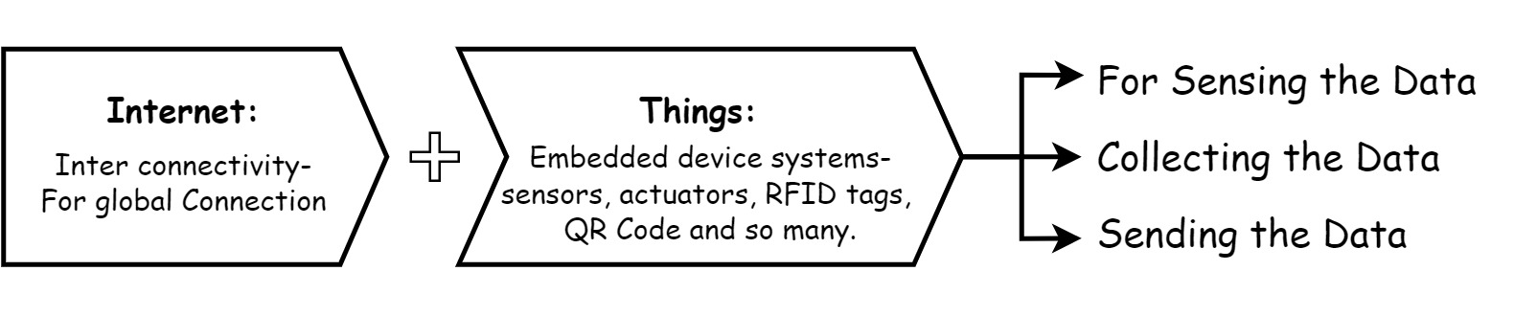
In other words,
The globally ruling technology acting as a single key to shrinking this whole universe to a tiny globally connected village, whereas IoT comprises of just two words which precisely depicts its definition.
Figure 1: Introduction to IOT

- Main Components of IOT:
- Low-power embedded systems –
Less battery consumption, high performance are the inverse factors play a significant role during the design of electronic systems.
- Cloud computing –
Data collected through IoT devices is massive and this data has to be stored on a reliable storage server. This is where cloud computing comes into play. The data is processed and learned, giving more room for us to discover where things like electrical faults/errors are within the system.
- Availability of big data –
We know that IoT relies heavily on sensors, especially real-time. As these electronic devices spread throughout every field, their usage is going to trigger a massive flux of big data.
- Networking connection –
In order to communicate, internet connectivity is a must where each physical object is represented by an IP address. However, there are only a limited number of addresses available according to the IP naming. Due to the growing number of devices, this naming system will not be feasible anymore. Therefore, researchers are looking for another alternative naming system to represent each physical object.

- Transducers Sensors and Actuators:
- Transducers:
There are many variables which affect our everyday lives: the speed of a car, the velocity of the wind, and the temperature in a home. In most situations these variables are continuously monitored. It is these variables that are the feedback that is used to control the speed of a car, the operation of an air conditioner, heater levels, and oven temperatures. The elements that sense these variables and convert them to a usable output are transducers. For example, a transducer known as a thermocouple, is able to sense changes in temperature and produce output voltages representative of those changes.
A transducer is defined as a substance or a device that converts (or transfers) an input energy into a different output energy. Because of this broad definition, transducers come in many varieties converting many different types of energy.
Following are different types of transducers:
- Electrochemical Transducers:
- pH probe – Converts chemical energy into an electrical energy
- Molecular electric transducer – Converts motion in an electrolytic solution into electrical energy
- Battery – Converts chemical energy directly into electrical energy
- Fuel cell – Converts the energy from a reaction within a fuel cell to electrical energy
- Electroacoustic, Electromagnetic, Electrostatic Transducers:
  - Loudspeaker – Converts an electrical signal into sound
  - Microphone – Converts sound waves in air into an electrical signal
  - Hydrophone - Converts sound waves in water into an electrical signal.
  - Magnetic cartridge – Converts motion in a magnetic field into an electrical energy
  - Generator – Converts motion in a magnetic field into electrical energy
  - Electrometer – Converts static or energy from a vibrating reed into electricity
  - Van de Graaf generator – Converts static into high voltage
- Electromechanical transducers (Also called actuators):
- Strain gauge – Converts the deformation (strain) of an object into electrical resistance
- Galvanometer – Converts the electric current of a coil in a magnetic field into movement
- Generators – Converts mechanical energy (motion) into electrical energy.
- Motor – Converts electrical energy into mechanical energy
- Photoelectric Transducers:
- Cathode ray tube (CRT) –Converts electrical signals into light energy for a visual output
- Light bulb –Converts electrical energy into visible light and heat
- Laser diode – Converts electrical energy into light energy
- Photodiode - Converts light energy into electrical energy
- Thermoelectric Transducers:
- Thermocouple – Converts heat energy into electrical energy
- Temperature sensitive resistor (Thermistor) – a variable resistor affected by temperature changes (heat energy to electrical energy)
- Other types of transducers:
- Geiger-Müller tube – Converts radioactive energy into electrical energy
- Quartz Crystal – Converts mechanical stress into electricity (electrical energy)
- Sensors:
Sensors detect the presence of energy, changes in or the transfer of energy. Sensors detect by receiving a signal from a device such as a transducer, then responding to that signal by converting it into an output that can easily be read and understood. Typically, sensors convert a recognized signal into an electrical – analog or digital – output that is readable. In other words, a transducer converts one form of energy into another while the sensor that the transducer is part of converts the output of the transducer to a readable format.
Transducers convert one form of energy to another, but they do not quantify the conversions. The light bulb converts electrical energy into light and heat; however, it does not quantify how much light or heat. A battery converts chemical energy into electrical energy but it does not quantify exactly how much electrical energy is being converted. If the purpose of a device is to quantify an energy level, it is a sensor.
Following are different types of sensors which are classified by the type of energy they detect:
- Thermal Sensors:
- Thermometer – measures absolute temperature
- Thermocouple gauge– measures temperature by its effect on two dissimilar metals
- Calorimeter – measures the heat of chemical reactions or physical changes and heat capacity
- Mechanical Sensors:
- Pressure sensor – measures pressure
- Barometer – measures atmospheric pressure
- Altimeter – measures the altitude of an object above a fixed level
- Liquid flow sensor – measures liquid flow rate
- Gas flow sensor – measures velocity, direction, and/or flow rate of a gas
- Accelerometer – measures acceleration
- Electrical Sensors:
- Ohmmeter – measures resistance
- Voltmeter – measures voltage
- Galvanometer – measures current
- Watt-hour meter – measures the amount of electrical energy supplied to and used by a residence or business
- Chemical Sensors:
- Oxygen sensor – measures the percentage of oxygen in a gas or liquid being analyzed
- Carbon dioxide detector – detects the presence of CO2
- Optical Sensors:
- Light sensors (photodetectors) – detects light and electromagnetic energy
- Photocells (photoresistor) – a variable resistor affected by intensity changes in ambient light.
- Infra-red sensor – detects infra-red radiation
- Acoustic Sensors:
- Seismometers – measures seismic waves
- Acoustic wave sensors – measures the wave velocity in the air or an environment to detect the chemical species present
- Other Sensor types:
- Motion – detects motion
- Speedometer – measures speed
- Geiger counter – detects atomic radiation
- Biological – monitors human cells
- Actuators:
An actuator is something that actuates or moves something. More specifically, an actuator is a device that coverts energy into motion or mechanical energy. Therefore, an actuator is a specific type of a transducer.
- Thermal Actuators: One type of thermal actuator is a bimetallic strip. This device directly converts thermal energy into motion. This is accomplished by utilizing an effect called thermal expansion
- Electric Actuators: An electric motor is a type of an electric actuator
- Mechanical Actuators: Mechanical actuators convert a mechanical input (usually rotary) into linear motion. A common example of a mechanical actuator is a screw jack.

- IoT protocols:
IoT communication protocols are modes of communication that protect and ensure optimum security to the data being exchanged between connected devices.
The IoT devices are typically connected to the Internet via an IP (Internet Protocol) network. However, devices such as Bluetooth and RFID allow IoT devices to connect locally. In these cases, there’s a difference in power, range, and memory used. Connection through IP networks are comparatively complex, requires increased memory and power from the IoT devices while the range is not a problem. On the other hand, non-IP networks demand comparatively less power and memory but have a range limitation.
As far as the IoT communication protocols or technologies are concerned, a mix of both IP and non-IP networks can be considered depending on usage. IoT protocols and standards can be broadly classified into two separate categories:

- IoT Network Protocols:
IoT network protocols are used to connect devices over the network. These are the set of communication protocols typically used over the Internet. Using IoT network protocols, end-to-end data communication within the scope of the network is allowed. Following are the various IoT Network protocols:

- HTTP (HyperText Transfer Protocol):
HyperText Transfer Protocol is the best example of IoT network protocol. This protocol has formed the foundation of data communication over the web. It is the most common protocol that is used for IoT devices when there is a lot of data to be published. However, the HTTP protocol is not preferred because of its cost, battery-life, energy saving, and more constraints.
Additive manufacturing/3D printing is one of the use cases of the HTTP protocol. It enables computers to connect 3D printers in the network and print three-dimensional objects and pre-determined process prototypes.

- LoRaWan (Long Range Wide Area Network):
It is a long-range low power protocol that provides signal detection below the noise level. LoRaWan connects battery operated things wirelessly to the Internet in either private or global networks. This communication protocol is mainly used by smart cities, where there are millions of devices that function with less power and memory.
Smart street lighting is the practical use case of LoRaWan IoT protocol. The street lights can be connected to a LoRa gateway using this protocol. The gateway, in turn, connects to the cloud application that controls the intensity of light bulbs automatically based on the ambient lighting, which helps in reducing the power consumption during day-times.

- Bluetooth:
Bluetooth is one of the most widely used protocols for short-range communication. It is a standard IoT protocol for wireless data transmission. This communication protocol is secure and perfect for short-range, low-power, low-cost, and wireless transmission between electronic devices. BLE (Bluetooth Low Energy) is a low-energy version of Bluetooth protocol that reduces the power consumption and plays an important role in connecting IoT devices.
Bluetooth protocol is mostly used in smart wearables, smartphones, and other mobile devices, where small fragments of data can be exchanged without high and memory. Offering ease of usage, Bluetooth tops the list of IoT device connectivity protocols.

- ZigBee:
ZigBee is an IoT protocol that allows smart objects to work together. It is commonly used in home automation. More famous for industrial settings, ZigBee is used with apps that support low-rate data transfer between short distances.
Street lighting and electric meters in urban areas, which provides low power consumption, use the ZigBee communication protocol. It is also used with security systems and in smart homes.

- IoT Data Protocols:
IoT data protocols are used to connect low power IoT devices. These protocols provide point-to-point communication with the hardware at the user side without any Internet connection. Connectivity in IoT data protocols is through a wired or a cellular network. Some of the IoT data protocols are:

- Message Queue Telemetry Transport (MQTT):
One of the most preferred protocols for IoT devices, MQTT collects data from various electronic devices and supports remote device monitoring. It is a subscribe/publish protocol that runs over Transmission Control Protocol (TCP), which means it supports event-driven message exchange through wireless networks.
MQTT is mainly used in devices which are economical and requires less power and memory. For instance, fire detectors, car sensors, smart watches, and apps for text-based messaging.

- Constrained Application Protocol (CoAP):
CoAP is an internet-utility protocol for restricted gadgets. Using this protocol, the client can send a request to the server and the server can send back the response to the client in HTTP. For light-weight implementation, it makes use of UDP (User Datagram Protocol) and reduces space usage. The protocol uses binary data format EXL (Efficient XML Interchanges).
CoAP protocol is used mainly in automation, mobiles, and microcontrollers. The protocol sends a request to the application endpoints such as appliances at homes and sends back the response of services and resources in the application.

- Advanced Message Queuing Protocol (AMQP):
AMQP is a software layer protocol for message-oriented middleware environment that provides routing and queuing. It is used for reliable point-to-point connection and supports the seamless and secure exchange of data between the connected devices and the cloud. AMQP consists of three separate components namely Exchange, Message Queue, and Binding. All these three components ensure a secure and successful exchange and storage of messages. It also helps in establishing the relationship of one message with the other.
AMQP protocol is mainly used in the banking industry. Whenever a message is sent by a server, the protocol tracks the message until each message is delivered to the intended users/destinations without failure.

- Machine-to-Machine (M2M) Communication Protocol:
It is an open industry protocol built to provide remote application management of IoT devices. M2M communication protocols are cost-effective and use public networks. It creates an environment where two machines communicate and exchange data. This protocol supports the self-monitoring of machines and allows the systems to adapt according to the changing environment.
M2M communication protocols are used for smart homes, automated vehicle authentication, vending machines, and ATM machines.

- Extensible Messaging and Presence Protocol (XMPP):
The XMPP is uniquely designed. It uses a push mechanism to exchange messages in real-time. XMPP is flexible and can integrate with the changes seamlessly. Developed using open XML (Extensible Markup Language), XMPP works as a presence indicator showing the availability status of the servers or devices transmitting or receiving messages.
Other than the instant messaging apps such as Google Talk and WhatsApp, XMPP is also used in online gaming, news websites, and Voice over Internet Protocol (VoIP).

- IoT Protocols Offers a Secured Environment for Exchange of Data
- As per an article published by Forbes, approximately “32,000 smart homes and businesses are at risk of leaking data.” Therefore, it becomes important to explore the potentials of IoT protocols and standards, which creates a secure environment. Using these protocols, local gateways and other connected devices can communicate and exchange data with the cloud.

Conclusion:

Experiment No: 1B
Getting Started with Infi IoT Cloud platform

Aim: To Sign-up/Sign-in and explore Infi IoT Cloud

Description:

What are IoT Cloud Platforms?
To bring physical objects online and make them communicate, cooperate and act intelligently without human intervention, the Internet of Things relies on IoT platforms to enable provisioning, management, and automation of smart objects within a given IoT infrastructure. Generally speaking, each IoT environment is a mashup of technologies by various vendors that form a complex and inherently diverse ecosystem which, without a common base for their integration, would stay fragmented, ‘dumb’, and, ultimately, unable to function. Therefore, it can be said that an IoT platform provides a ‘meeting point’ for all the connected devices and serves to collect and handle the data they deliver over the network.
At the other end of the Internet of Things cloud solution, there is cloud computing. Breathing new life into IT services, cloud computing is the latest technology buzz that has moved consumer and business applications to the web, thus enabling enterprises to optimise their IT performance and reduce costs that would be otherwise bloated by the need of creating and maintaining on-site IT architecture for storing data and running applications. Cloud-based solutions are not only more cost-effective in the long run; they also provide better security, corporate data mobility, increased co-worker collaboration, more advanced disaster recovery solutions, to name only a few benefits. What is more, cloud computing offers more flexibility which helps to shift the company’s focus from IT hosting-related issues towards aspects directly affecting its business bottom-line.

Infi IoT Cloud Platform
Infi Iot is an Advance IoT development platform for connecting devices to the cloud and to remotely monitor and manage these devices.
Infi Iot provides features such as dashboards, automated data integration, Upload your past data, device alerts, notifications and the most amazing Analytics.
Get started with your project ideas connect your devices, control from platform, analyse your data and make future predictions with our unique IoT cloud platform

Specifications of IoT Cloud Platform:

- Future prediction – use historical and transactional data to predict future machine-related metrics, and to identify potential risks to your machines. Use predictions to identify risks, carry out proactive maintenance of machines, and avoid product delivery delays. Predictions help to create and meet production plans for Industries. Predictions help warn you of impending machine failure in advance. Preventive maintenance can help save the costs associated with machine breakdown or unavailability.
- Multi-Threaded Interface – is the ability of an operating system process to manage its use by more than one user at a time and to even manage multiple requests by the same user without having to have multiple copies of the programming running in the computer.
- AES Secure Payloads – AES is a symmetric block cipher with a block length of 128 bits. It allows using three different key lengths: 128, 192 or 256 bits. The encryption/ decryption algorithm consists of several rounds of processing; the number of rounds depends on the key length: 10 rounds for 128-bit keys, 12 rounds for 192-bit keys and 14 rounds for 256-bit keys. Except for the last round, all other rounds are identical. The rounds in-order are one single-byte based substitution, row-wise permutation, column-wise mixing, addition of the round key.
- IoT Protocols – IoT data protocols are used to connect low power IoT devices. These protocols provide point-to-point communication with the hardware at the user side without any Internet connection. Connectivity in IoT data protocols is through a wired or a cellular network. Refer Experiment 1A for more information.
- User Authentication – User authentication is a process that allows a device to verify the identity of someone who connects to a network resource. Authentication is very important when you use dynamic IP addressing (DHCP) for computers on the trusted or optional network. It is also important if you must identify your users before you let them connect to resources on the external network.
- No setup – Setup are the sequence of process must be carried to setup a Cloud service and get started sending data to Cloud, it may include signing up/in, creating projects, defining hardware, Creating variables and widgets. Infi IoT don’t require any
- Export/Import csv – This Feature allows user to save logged data onto local systems by exporting as csv file, this helps user to use the data and perform analytics. Similarly, if user already have logged data, it can be uploaded using the import option on the cloud. This helps in utilizing past data for analytics and in making future predictions.

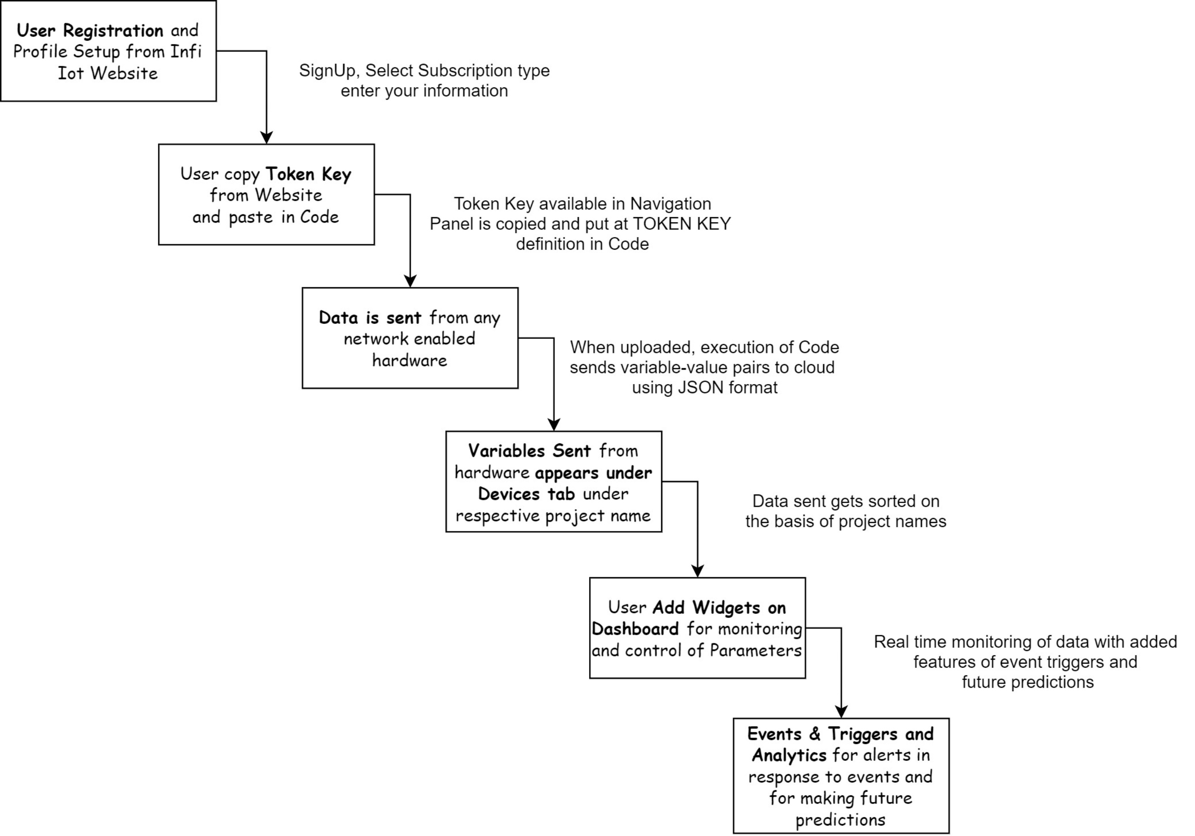
So How does Infi IoT Cloud Work?
Figure 2: Design Flow Infi IoT
Procedure:
Specifications of IoT Cloud Platform
Step 1.)

